3. ReactJS-HOL.docx:
Create a react app with name scorecalculatorapp and open it in the vs code.
Create a components folder inside the src folder.
Inside the components folder create a file with the name CalculateScore.js
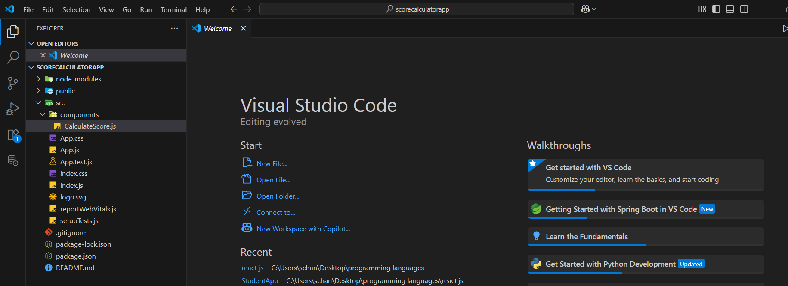
Create a folder to store styles sheets
Create a folder with the name Stylesheets. Inside it create file with the name mystyle.css to write styles for tags/elements of the CalculateScore.js
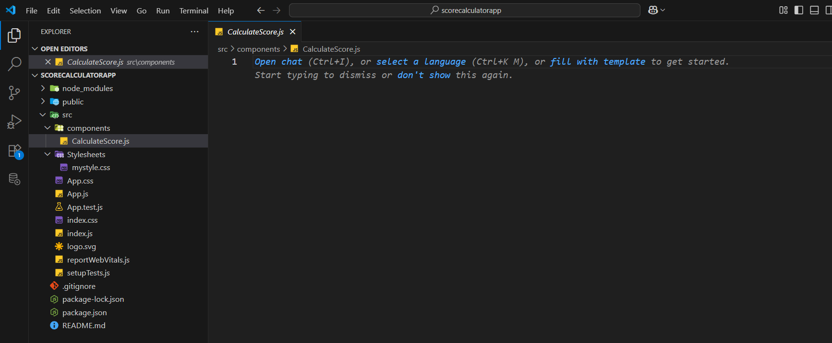

App.js:
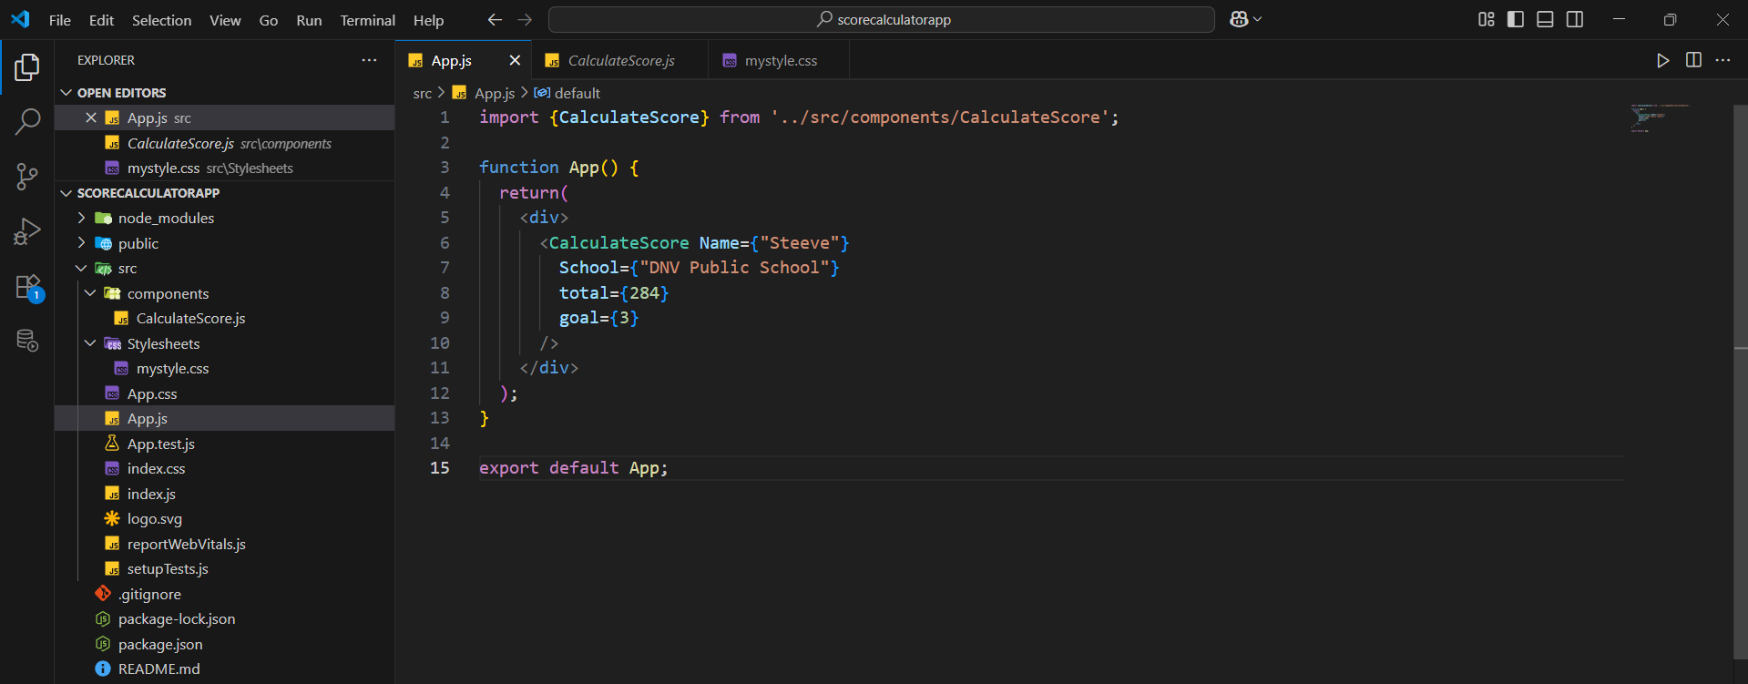
CalculateScore.js:
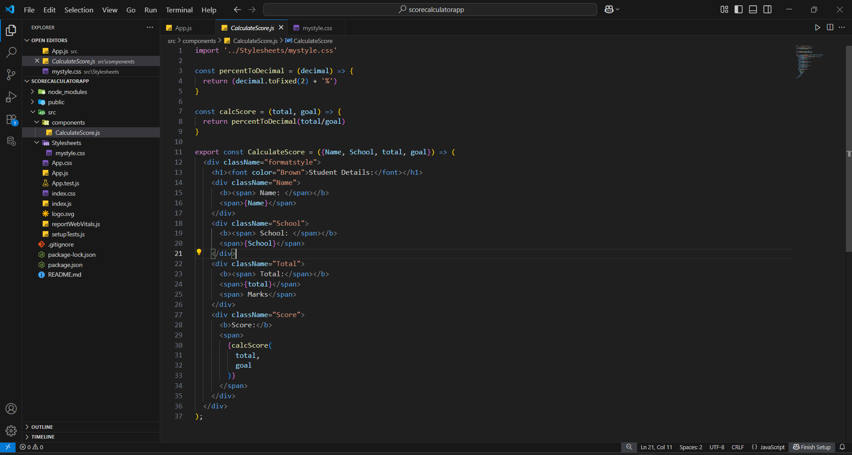

mystyle.css:
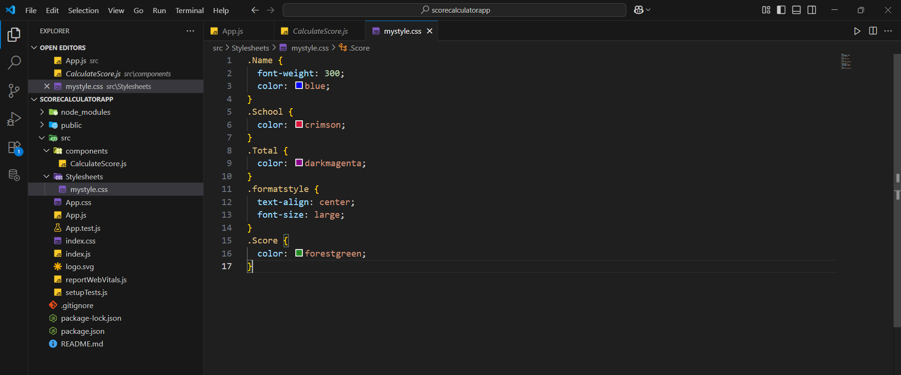
Output:
